9814 Kensington Parkway
Kensington, Maryland 20895
January 29, 2012

Honorable Jane Lubchenco, Ph.D.
Under Secretary of Commerce for Oceans and Atmosphere and
Administrator, National Oceanic and Atmospheric Administration
14th and Constitution Avenue, NW
Washington D.C. 20230

Re: Atlantic White Marlin – Reconsideration to “List” as a “Threatened” or an “Endangered Species”
Dear Dr. Lubchenco;
In rejecting our 2001 petition (filed jointly by the Biodiversity Legal Foundation and myself) to “list” Atlantic white marlin as a “threatened” or an “endangered species” and then to protect it under authority of the Endangered Species Act, the National Oceanic and Atmospheric Administration (NOAA) stated the Atlantic white marlin was not in danger of extinction (the definition of “endangered”) until its population had declined to 1% of its unfished level of abundance (which population modelers term K) – a level which existed until about 1960 when longlines were first introduced. NOAA did not make any determination on what abundance level would constitute a “threatened species.” Nevertheless, in making its ruling, the agency stated it would revisit its decision if information became available in the future that indicated the species’ population had declined to the “endangered” level. We now have such information. It is presented in the latest (2011) Marlin stock assessment by the International Commission for the Conservation of Atlantic Tunas (ICCAT). I am asking that the agency hold to its promise of reevaluating its listing decision.
We developed our petition because (as shown in ICCAT’s figures below) by 1999, its population had declined to approximately 6% of an unfished (1960) level of abundance and it had been declining at a rate of 2% per year for over a decade. The cause (shown in ICCAT’s figure below right) was excessive and rapidly escalating fishing mortality - 8 times the appropriate level and still increasing rapidly as of 1999.
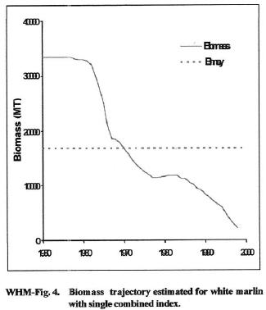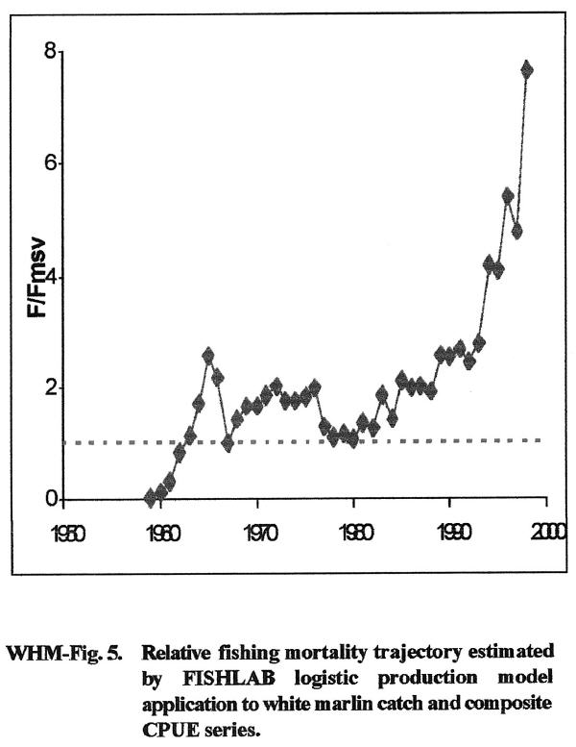

ICCAT claims its objective is to manage fishing by its member states so that all stocks produce the maximum sustainable yield or MSY (indicated above by horizontal dashed lines). However the Atlantic white marlin’s population has been allowed to decline far below this level. It is well below the level at which there is a danger of recruitment failure which is considered to begin at 50% of MSY (or approximately 25% of an unfished population). Passing such a threshold means there are becoming too few breeders to replace the population, which can then spiral ever faster towards extinction. Since the commercial vessels are targeting other species such as swordfish and yellowfin tuna whose populations are far larger, the incidental kill of both white and blue marlin will continue until it becomes unprofitable to target the “money fish.” Yellowfin tuna and swordfish, for example, are estimated to still be near the MSY abundance level, and, if true, they can withstand a great deal more commercial fishing pressure.
Atlantic White (and Blue) Marlin Populations Nearing Extinction
Shown below is the total reported Atlantic-wide catch of both blue and white marlin between 1990 and 2007 (from ICCAT's 2011 Stock Assessment Summary Report). Both populations are getting dangerously low. 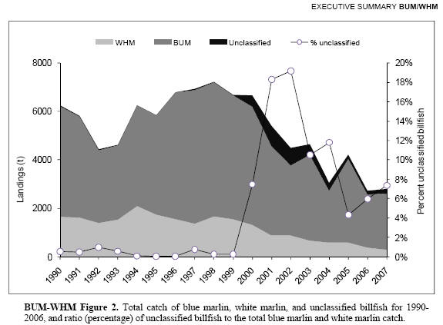
But the decline of the Atlantic white marlin population is much more serious. By 1999 when our petition was filed, abundance had declined to about 6% of its unfished level. But after 8 more years of monitoring, it apparently had declined by an additional two thirds (as reflected in the decline in Atlantic-wide catch, above). This means it may have fallen to about 2% of an unfished level of abundance by the end of 2007. According to this portrayal, it will intersect the zero line (extinction) in less than 10 years (before 2017), unless something dramatic is done to reverse this long-term trend which started in 1994.
Also, according to ICCAT stock assessments, the Atlantic blue marlin population had been driven down to about 20% of its unfished abundance by the end of 1999. But since then, as shown above, the Atlantic-wide catch is falling rapidly and by the end of 2007 had declined by half its 1999 level, meaning it had fallen to about 10% of an unfished level of abundance. This is a decline of about 10% in just 8 years, and it appears to still be declining and declining more rapidly than is the white marlin. At this population’s rate of decline since 1999 it will intersect zero about the same time as white marlin (2017).
In our judgment, extinction is imminent and Atlantic white marlin ought to be declared an “endangered species” now. Atlantic blue marlin ought to be declared a “threatened species” now since at 10% in 2007 and declining much more rapidly, it is likely to become endangered within the foreseeable future (the definition of “threatened” under the Act).

TWO SEPARATE POPULATIONS - ONE ON EACH SIDE OF THE EQUATOR
Based on all the information available, we are convinced that there is not one Atlantic-wide population of white marlin (or blue marlin), but two - one in each hemisphere. Both spawn in the spring, but spring occurs 6 months later south of the Equator. The South Atlantic sub-populations of both blue and white marlin appear to spawn primarily off the northeast coast of Brazil (Royal Charlotte Bank area, a large submerged plateau much like Georges Bank off Massachusetts) during late spring-early summer in the southern hemisphere (probably peaking in November-early December). The North Atlantic sub-populations ("our" white and blue marlin) spawn in the Caribbean region during late spring-early summer (peaking from gonad examinations in May-early June). From the 10 years of longline catch records by quarter (see www.bigmarinefish.com/critical_habitat_white_marlin.html) we know that it is most probably concentrated in the large gaps between the larger islands of the Caribbean (such as the Mona Passage between the Dominican Republic and Puerto Rico where concentrations of larval white marlin have been found). Thus, spawning by the North and South Atlantic sub-populations of both white marlin and blue marlin occurs 6 months apart and the two centers of spawning activity are separated by 4,000 miles of ocean. Clearly (for both the white marlin and the blue marlin), these are not single Atlantic-wide populations, but two entirely distinct sub-populations which do not interbreed. The same is already accepted by the international scientific community for North and South Atlantic swordfish - 2 separate and distinct sub-populations, one in each hemisphere. Therefore, overfishing on one sub-population of any of these three species (swordfish, blue marlin or white marlin) will have no effect on the other sub-population. Moreover, combining the North and South Atlantic populations of white and blue marlin also masks the magnitude of decline of the North Atlantic populations which have been subjected to intensive commercial fishing (longlines) longer and whose populations are thus more severely depleted. Shown below is the total reported catch of "our" white marlin from the North Atlantic between 1956 (when longlines were first introduced) and 2010 (source: ICCAT's 2011 Marlin Stock Assessment). Since 1999, when we filed our petition, the total North Atlantic catch has declined by at least two thirds (almost exclusively due to longlines). It was at 6% of an unfished population then and as shown below is now down to about 2% and marching steadily toward oblivion.
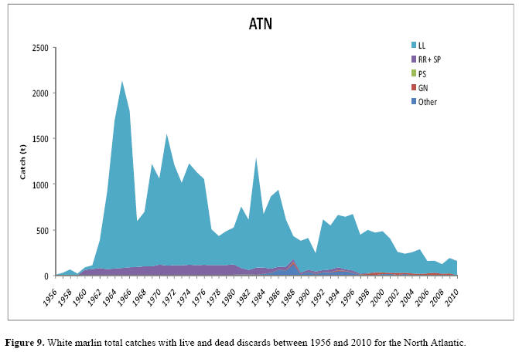

WHAT IMMEDIATE ACTION IS NEEDED? -- CLOSE THE "HOT SPOTS" TO LONGLINES
We refer to the white marlin's (and blue marlin's) critical habitats - their primary spawning sites and feeding grounds - as their "hot spots." Their spawning sites which are small and distinct are used year-after-year. They have been mapped based on 10 years of U.S. longline catch records reported to NMFS. To see the locations of their prime spawning sites and feeding areas, and the specific areas under U.S. jurisdiction that we have recommended for closure to longlines, go to www.bigmarinefish.com/hot_spot_closures.html
These "hot spots" are not just the areas where the longliners fish most heavily. As can be seen in plots showing the yearly extent of U.S. longline vessels' sets (see www.bigmarinefish.com/map_longline_sets_1997.html), longliners are covering a much greater area of the North Atlantic than just the area of these "hot spots." In fact, we estimate that closing all the white marlin's "hot spots" in the North Atlantic would deny U.S. longliners access to only about 2% of the area they normally fish. But, it would eliminate about 85% of their interactions with white (and blue) marlin.
We may not be able to save South Atlantic’s white marlin or blue marlin because that is totally dependent on international agreements at ICCAT. But, the U.S. can unilaterally protect the North Atlantic sub-populations (of both marlins) to a great extent by prohibiting longlining in those "hot spots" located in U.S. waters. This is true simply because, except for spawning, most of the sub-population's members apparently spend a large part of their adult life in U.S. waters. This is particularly true of white marlin and less so for blue marlin and swordfish which range farther out into the mid-Atlantic (the site of the movie "The Perfect Storm") during summer through fall following (the edges of) the Gulf Stream. All three species, however, appear to use the same very small and distinct areas in the Caribbean region as their primary spawning sites. The most important "hot spots" are used at the same time of year and for the same purposes (both spawning and feeding) by not only the North Atlantic white marlin sub-population, but also the North Atlantic sub-populations of swordfish and blue marlin. So, closing them to longlines to protect white marlin will also markedly benefit blue marlin and swordfish as well.
Obtaining these closures and reducing the kill of white marlin accordingly is the primary objective of our ESA petition. It requests that the U.S. government first "list" the white marlin as either "threatened" or as "endangered" and then protect it and its critical habitats (its "hot spots") under authority of the Endangered Species Act.
For more detail on the decline of Atlantic white and blue marlin (as well as bluefin tuna and swordfish) see www.BigMarineFish.com/marlin.html.

Sincerely,

/S/

James R. Chambers
jim@primeseafood.com
301-949-7778

