
PRIME SEAFOOD

"Sustainable Seafood for our Best Restaurants"
9814 Kensington Parkway, Kensington, MD 20895
jim@primeseafood.com 301-949-7778 www.PrimeSeafood.com

November 24, 2011

Honorable Jane Lubchenco, Ph.D.
Under Secretary of Commerce for Oceans and Atmosphere and
Administrator, National Oceanic and Atmospheric Administration
14th and Constitution Avenue, NW
Washington D.C. 20230

Re: North Atlantic Swordfish Management

Dear Dr. Lubchenco;

I am writing to ask how the National Oceanic and Atmospheric Administration (NOAA) and the National Marine Fisheries Service can consider the North Atlantic swordfish population to have “fully recovered” to its Maximum Sustainable Yield (MSY) level, from a severely overfished condition which existed at the end of 1998 in just two years with no significant decrease in total North Atlantic catches reported since then by the 48 member states of the International Commission for the Conservation of Atlantic Tunas (ICCAT).

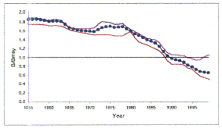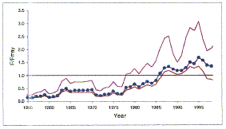
According to ICCAT’s scientific advisory committee, by the end of 1998, North Atlantic swordfish abundance (or biomass) had been driven down to only 65 percent of that needed to produce the MSY (indicated in ICCAT’s figure on the left as a dotted horizontal line at 1.0). An unfished or "virgin" population level would be a biomass of 2 times MSY level. This stock was last at a healthy level in 1978. As shown by ICCAT’s 1999 stock assessment, it has declined steadily and dramatically every year since. The fishing pressure exerted on this population, and the cause of the decline in abundance, is portrayed in the figure to the right. Fishing pressure should never be allowed to exceed the level that would produce MSY (again represented by the horizontal line at 1.0). Unfortunately, fishing pressure at the end of 1995 was estimated to be nearly double the rate that the stock can sustain (MSY). Consequently, the stock continued to decline.
The 1999 stock assessment used catch data through 1998. The population was then close to 50% of the MSY level - considered the threshold for recruitment failure. Beyond that point (below 50% of MSY) the population would have too few adults to sustain itself and, unless fishing pressure was reduced, it would continue to spiral downward. Eventually a point will be reached at which there are too few adults remaining to find each other for spawning. When that occurs, the population will decline to extinction even if all fishing were to be stopped.
A new stock assessment was conducted in 2002 using catch data through 2001. It depicts a dramatic increase in biomass even as both catch and catch per unit effort continued to decline. We believe this apparent abundance increase is not real, but contrived, beginning the very next year. The Japanese submitted catch data showing huge discards of very small swordfish in 2000 through 2003 (about 600 metric tons and twice that of the U.S. and Canada's, combined) after never previously reporting, as required by ICCAT, any discards. They must have known this would cause the stock assessment model to wrongly assume there had been an enormous increase in reproduction and survival and thus a larger population building. (Japan, like any ICCAT member country, can submit any information it wants because there are no independent observers.) During these same 4 years, Japan reported landing essentially no legal-size swordfish after previously reporting many years of landings averaging about 1,400 metric tons per year. This would also dramatically skew the model's results. Why?
We suspect that the Japanese believed that if ICCAT's estimates of swordfish (or bluefin tuna) biomass showed a continuing decline (as depicted above and at our website, www.BigMarineFish.com/bluefin.html) it might be forced to limit its catches thus affecting Japan's extensive fleet targeting tuna and swordfish throughout the Atlantic. In this context, it is important to recognize that Japan was recently exposed by the Australian government for having lied for many years about the tonnage of Southern Bluefin Tuna - a severely overfished stock subject to intense conservation efforts - it had been catching off Australia. Apparently, none of the Japanese catch data for tuna or swordfish can now be trusted, nor can stock assessments based in significant part on their data. Accordingly, we consider the abundance estimates from all ICCAT's swordfish stock assessments since 2000 to be bogus. With no real change in total annual landings, the stock of North Atlantic swordfish could not miraculously recover from "severely overfished" - the status portrayed in the figures above - in just two years as ICCAT would have us believe. This "full recovery" apparently has been manufactured by the submission to the stock assessment committee of intentionally misleading catch information, apparently just as the Japanese did for the Southern Bluefin Tuna stock assessments. However, it is curious that none of the scientists on this ICCAT committee, including several NOAA employees, have "blown the whistle" and publicly exposed this obvious charade that began in 2001 and continues today. The population decline between 1990 and 2007 in both the North and South Atlantic (2 separate stocks) is even evident in ICCAT's most recent stock assessment (below):
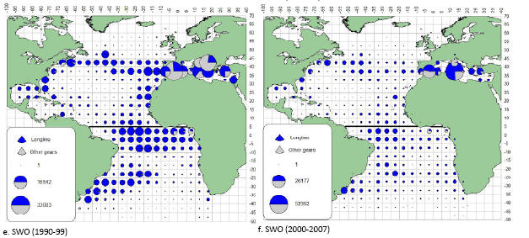
First, the North Atlantic stock has been largely eliminated by overfishing and now, apparently, so too has the South Atlantic. (As we show on our Bluefin webpage, the South Atlantic bluefin tuna stock, which ICCAT participants didn't even realize existed, was actually extirpated in just 10 years, 1960-1970.)
In light of the above, I ask that the North Atlantic swordfish stock assessment be objectively evaluated by independent experts to determine whether the “full recovery” NOAA reports annually to Congress is real or has been manufactured by the submission of misleading information, and if so, to make your findings known to Congress, the public and ICCAT.

Sincerely,

/S/

James R. Chambers
Founder/Owner

cc: Eric Schwaab, Assistant Administrator for Fisheries

