
PRIME SEAFOOD

"Sustainable Seafood for our Best Restaurants"
9814 Kensington Parkway, Kensington, MD 20895
jim@primeseafood.com 301-949-7778 www.PrimeSeafood.com

November 9, 2011

Dr. Jane Lubchenco
Under Secretary of Commerce for Oceans and Atmosphere and
Administrator, National Oceanic and Atmospheric Administration
14th and Constitution Avenue, NW
Washington D.C. 20230

Re: Bluefin Tuna Management

Dear Dr. Lubchenco;

I am writing to ask that the National Oceanic and Atmospheric Administration (NOAA) fulfill its responsibility as the federal steward of the nation’s living marine resources, specifically for the critically endangered western North Atlantic bluefin tuna population - “our” bluefin tuna - by acting to prevent the extirpation of this population as has already occurred for the South Atlantic bluefin tuna population. Bluefin once roamed the entire Atlantic Ocean but excessive fishing in their concentration areas has already forced the South Atlantic population into extinction as recorded in ICCAT's latest stock assessment (p. 13 of the Detailed Report), reproduced below.
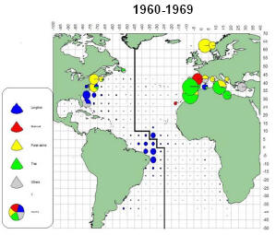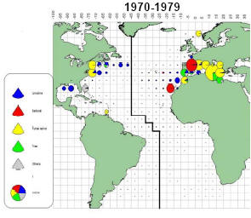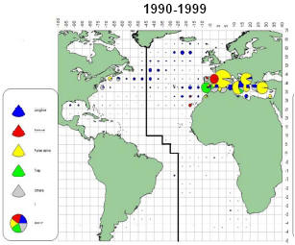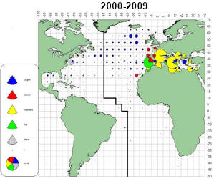

This population spawned off the northeastern coast of Brazil (in the area of highest catches) at the same time and in the same general area as do South Atlantic blue marlin, white marlin and swordfish. None of these fish interbreed with their North Atlantic populations because spawning, which occurs during the spring for all of them, occurs in the Southern Hemisphere in November-December - 6 months later than north of the Equator. Within just 10 years of the introduction of longlines by the Japanese in 1960, this bluefin population which surely ranged throughout the South Atlantic had been extirpated and it is no longer caught there. To my knowledge, no one in the international scientific community is even aware of this separate population's former existence (as a distinct population unit) much less its extinction. The same cannot be allowed to happen to “our” bluefin population which is now poised on the edge of extinction.

The western North Atlantic bluefin tuna population, the most magnificent fish that ever lived, was last at a healthy level in 1960. But by 1990, industrial-scale commercial fishing on the world’s most valuable fish had reduced this population to about 3% of its 1960 abundance (below), according to SCRS stock assessment data developed by Dr. Pamela Mace (a population dynamics expert with NMFS’ Highly Migratory Species Management Division during my tenure there):

Western North Atlantic Bluefin Tuna
Spawning Stock Biomass

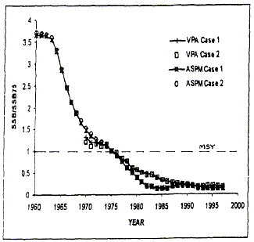

For obvious reasons, ICCAT scientists focus only on population trends since 1980, avoiding this embarrassing portrayal of ICCAT “mismanagement.” But, recent research conducted by Dr. Barbara Block’s team has shown that perhaps half of the population we thought we had left is actually Mediterranean-origin bluefin (eastern North Atlantic bluefin tuna). So, “our” bluefin population may have been reduced by the late 1990s to less than 1½ percent of its former “virgin” abundance. The stock assessment, conducted by ICCAT’s SCRS depicted below, indicated that the adult population is still continuing its slide toward extinction. At what point is extinction inevitable even if all fishing were to cease?

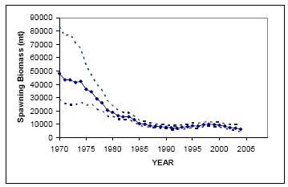

The point at which a declining population of marine fish is considered “at risk of extinction” under the Endangered Species Act, was decided by NMFS in the case of my petition (submitted jointly with the Biodiversity Legal Foundation) to “list” Atlantic white marlin as “threatened” or as “endangered.” (According to ICCAT’s latest stock assessment at the time, the Atlantic white marlin population had declined to 6% of its level in 1960 and had been falling at 2% every year for the previous decade or more.) NMFS took the position then that there would be no “risk of extinction” (the definition of “endangered” under the Act) until the population’s abundance had declined to 1%. Such a position is certainly not “risk averse” and further, it ignores the reality that public comment and rulemaking require two years to complete before any management action can even begin. In violation of the ESA, NMFS also failed to take a position on whether (and at what population level) the white marlin was “threatened,” just whether it was “endangered.”

NMFS’ mission is to act as the federal steward of the nation’s living marine resources. Since the western North Atlantic bluefin population is nearing the level NMFS has chosen (1%) to trigger a decision to “list” a species as “endangered” under the ESA, it is imperative that the agency cease trying to increase the mortality of our few remaining bluefin tuna and instead, begin to conserve the stock before it slides irreversibly into extinction. It can best do this by eliminating mortality in its primary spawning area in the north central Gulf of Mexico during the portion of the year when adult bluefin are using it - May through the first week of June.

I join others in urging NMFS to propose a prohibition on the use of surface longlines in the Gulf of Mexico during the annual bluefin tuna spawning season.

Sincerely,

/s/

James R. Chambers
Founder/Owner

cc: Eric Schwaab, Assistant Administrator for Fisheries

